SITE INSPECTION REQUEST FORM


Person Making Request Provider Agency
Site-Specific CRA Number or Application Tracking Number
Phone/Ext Email
Reason for Inspection: (mark only one category)

Date Emailed to Region

Region of Responsibility Targeted Move Date
Columbus ☐Creative ☐GA Supports ☐Professional
☐

- New Site
- Individual Move Within Agency (PPSV)
9 ☐ Temporary or ☐ Permanent
- New Admission to Agency (PPSV)
- Change of Address (COA)
- Site Conversion
- Emergency Respite ☐ Scheduled Respite
9 ☐ Within Region or ☐ Out of Region
SC Agency/PLA
SC or PLA Name SC or PLA
Supervisor Name
☐ PLA ☐ Compass ☐ Carestar ☐ Benchmark

SC/PLA Phone

Region to Region Transfer? List regions:

YES ☐ NO ☐

Potential New Individual for Placement
Name Age
Current Individual Residing in Home (if applicable)
Name Age Date
Placed

Axis I
Axis II
Axis III
- Male ☐Female
Axis I
Axis II
Axis III
- Male ☐Female

Assistance with Ambulation
YES ☐ NO ☐ Assistance with
Transfer
YES ☐ NO ☐
Assistance with Ambulation
Assistance with Transfer
YES ☐ NO ☐

Medical Needs and/or Equipment

Behavioral Challenges

AS for Behavioral or Medical Needs in Place
Likes/Dislikes/Hobbies
Yes ☐ No ☐
Specify:
Yes ☐ No ☐
Specify:
Yes ☐ No ☐
Specify:
Medical Needs and/or Equipment

Behavioral Challenges

AS for Behavioral or Medical Needs in Place
Likes/Dislikes/Hobbies
Yes ☐ No ☐
Specify:
YES ☐ NO
Yes ☐ No ☐
Specify:
Yes ☐ No ☐
Specify:

Current Individual Residing in Home (if applicable)
Name Age Date
Placed
Current Individual Residing in Home (if applicable)
Name Age Date
Placed

Axis I
YES ☐ NO ☐
Axis II
Axis III
- Male ☐Female
Axis I
Axis II
Axis III
- Male ☐Female

Assistance with Ambulation
Assistance with Transfer
YES ☐ NO ☐
Assistance with Ambulation
Assistance with Transfer
YES ☐ NO ☐

Medical Needs and/or Equipment

Behavioral Challenges

AS for Behavioral or Medical Needs in Place
Likes/Dislikes/Hobbies

Street
Yes ☐ No ☐
Specify:

Yes ☐ No ☐
Specify:
Yes ☐ No ☐
Specify:
Medical Needs and/or Equipment

Behavioral Challenges

AS for Behavioral or Medical Needs in Place
Likes/Dislikes/Hobbies

Instructions
Yes ☐ No ☐
Specify:
YES ☐ NO ☐

Yes ☐ No ☐
Specify:
Yes ☐ No ☐
Specify:

City Zip
County Phone
Regarding Home Location/Entry

Licensed PCH
YES ☐ NO ☐ Licensed CLA
YES ☐ NO ☐
Home near community resources? YES ☐ NO ☐

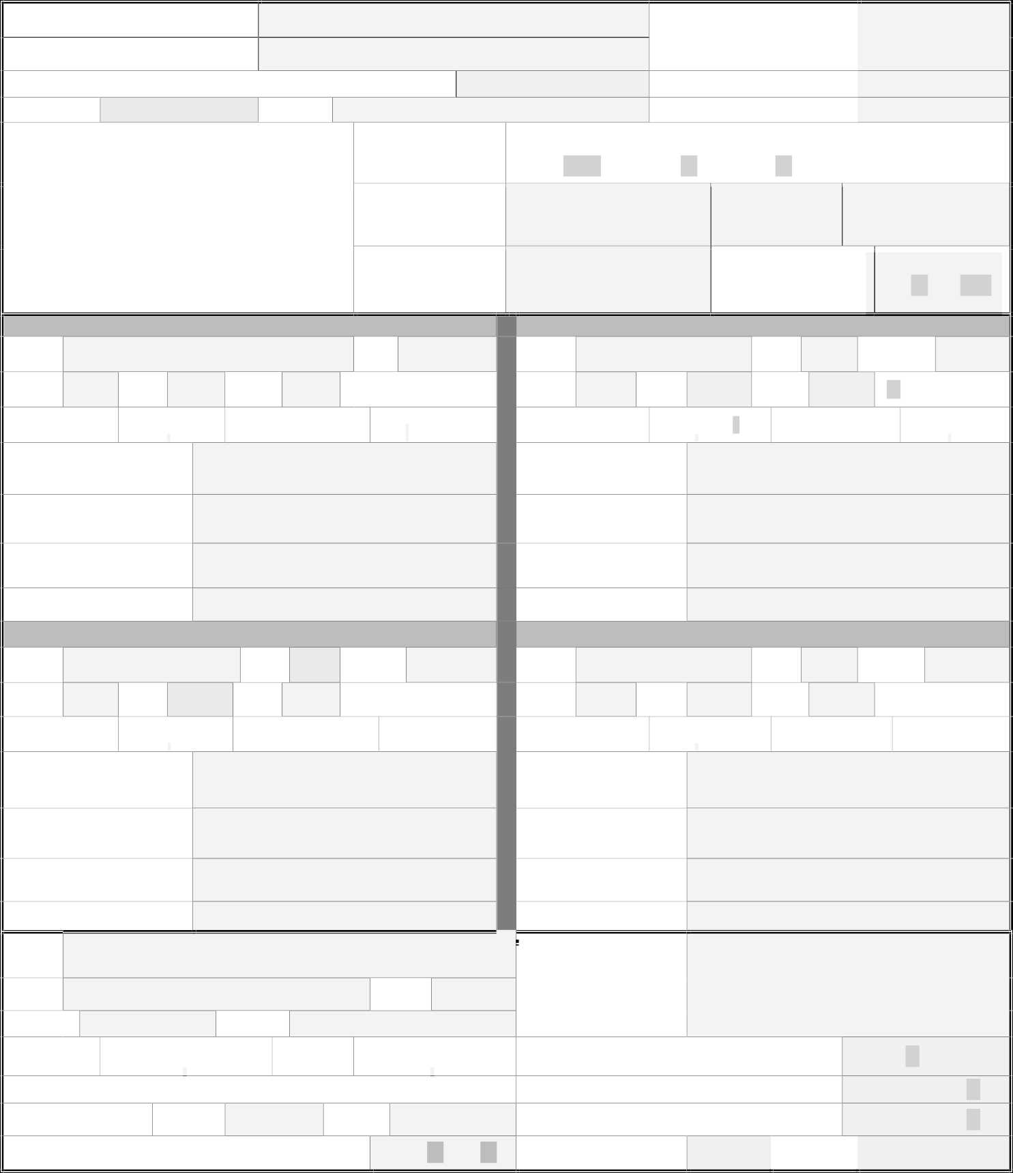
*CLA/PCH will not be processed without a copy of current license/permit.

License Date (From) (To) present
Has this license been verified at www.dch.georgia.gov? YES ☐ NO ☐
Host Home (Life-Sharing)**
**If YES, is Home Study attached?
Date License Verified Verified By
YES ☐ NO ☐
YES ☐ NO ☐

Only completed requests will be processed for approval. Once approved, the Regional Case Expeditor will forward correspondence to appropriate parties.

MET |  | SITE INSPECTION CHECKLIST
OVERALL CONDITION OF THE HOME
Home is clean. Free of debris, odor (mold/gas/etc.), clutter, trash and dust.
Heating and air conditioning systems are operational and provide adequate heat and air.
No needed repair work around the home, yard, deck.
The yard area is free from hazards, debris, and nuisances.
All areas are lighted sufficiently and fixtures are secured.
Provides an area for use by residents and visitors that affords privacy.
Furnishings and housekeeping present a clean and orderly appearance.
Provides common space, such as living room and kitchen, for use by the residents without restriction.
Garbage is stored/disposed of properly.
OVERALL SAFETY OF THE HOME
Residents dependent upon a wheelchair have at least 2 accessible exits.
One fully handicap accessible bathroom if applicable.
Space heaters are not present in home.
Stairways/ramps have handrails; exterior stairways/decks/porches w/handrails on open sides unless low to ground.
Sufficient AC powered smoke detectors with battery back-up (should keep record of when changed), or sufficient and operable smoke and carbon monoxide detectors.
Charged, 5 lb. multipurpose ABC fire extinguisher on each floor and basement, tagged by a fire extinguisher company. Staff should check the extinguisher monthly to verify it has a full charge; tag should be initialed/dated by staff after each check.
Exterior doors are equipped with locks that do not require keys to open the door from the inside.
The storage/disposal of biomedical and hazardous waste complies with applicable rules and standards.
Wall-mounted electric outlets and lamps or light fixtures are safe and operational.
Poisons, caustics, and dangerous materials are stored in labeled, appropriate containers away from medication & food.
Provides sufficient hot water not exceeding 120 degrees Fahrenheit.
An evacuation plan with clear instructions is provided, and a diagram is posted in CLA/PCH (posted diagram not required in HH).
Monthly Fire Drill Report forms are present in the home, noting that individuals evacuate in under 3 minutes; 13 minutes if sprinkler system is present.
Fireplace is securely screened and/or equipped with protective guards while in use.
Fireplace has been cleaned and verification from professional cleaning company is available for review.
Stairways, halls, doorways and exits from all rooms and house are unobstructed. Must be clear exit path in/out of garage.
Flammable and combustible supplies/equipment is stored away from heat sources.
Firearms owned and in the home are unloaded and secured in locked cabinet (for HH ONLY).
Sufficient safety precautions are taken to prevent unauthorized access to swimming pools, or any body of water.
All pets are current on vaccinations (if applicable).
KITCHEN/LAUNDRY
All appliances (microwave/stove/oven/refrigerator/freezer/disposal) are in good working order.
Provides laundering facilities, at minimum one washer and one dryer.
 |  | Food is stored properly.
Maintains a 3-day supply of non-perishable foods for emergency needs. All food should have expiration dates.
RESIDENT BEDROOMS
All bedrooms provide a minimum of 80 square feet for each resident in CLA/PCH or sufficient space in a HH.
All bedrooms have at least one window.
All bedrooms have standard non-portable bed with springs or a specialized bed. Mattress and bedding must be clean.
Sufficient bedding for all residents: Two sets of sheets/pillow/pillowcase/blanket/bedspread for each bed.
No bedroom is a pass-through to reach another room or bathroom.
All bedrooms have an adequate closet or wardrobe for each resident.
All Bedrooms have lighting fixtures sufficient for reading and other activities.
All bedrooms have doors that can be closed; no double-cylinder locks.
 |  | BATHROOMS
Provides at least one full functional bathroom.
Grab bars and non-skid surfacing are in all showers/bath areas.
Bath linens are present and sufficient (at least two sets per individual).

 |  |  | Bathrooms have a window that can be opened or forced ventilation fan.
 |  |  | Tub/shower has a shower curtain or door.
 |  |  | Plumbing/bathroom fixtures are in good working order and are clean.
 |  |  | Toilet tissue is available for use at each commode.
 |  |  | Hand-washing facilities have hot and cold running water, liquid soap, and paper towels.
 |  |  | HEALTH and SAFETY
 |  |  | Medications are stored appropriately and under lock/key; controlled substances are double locked.
 |  |  | Medical supplies are stored appropriately.
 |  |  | Supply of first-aid materials available w/band aids, antiseptic, gauze, tape, probe covers, and a thermometer in home.
 |  |  | First aid kit and fire extinguisher in vehicle.
 |  |  | Functioning seatbelts in all vehicles used to transport individuals
Notes and Information: *AC powered smoke detectors w/battery back- up not required in Host/Life Sharing Homes. Any boxes that are left blank should be explained in detail.
Date of Provider Site Inspection (prior to request to DBHDD) : |  |  |  |  | Site Inspection Completed By:
Request Completed By/Title: |  |  |  |  |  | Date Submitted:
Agency Contact and Telephone Number:
Approved By and Date: (DBHDD Staff)
 Provider must complete the initial inspection before the site visit request is sent to the Region

