Georgia Regional Hospital-Atlanta
Doctoral Internship in Clinical Psychology

Internship Brochure
Revised 8/27/21

Georgia Regional Hospital–Atlanta’s Main Building at Entrance

Table of Contents

Welcome……………………………………………………………………………………………………………………………...……3

Aim & Mission of the Internship………………………….………………………………………………………...………....3

Philosophy, Goals, & Training Objectives……………………………………………………..……...…………………...4

Overview of Internship & Orientation…………………………………………...………………………………………....5

Adult Mental Health Track (AMH)…………………………………………………………………………………...…...…..6

Forensic Track…………………………………………………………………………………………………………....…………..…6

Training Activities
Program Evaluation & Consultation (PEC) Project………………………………………………...……….6

Supervision……………………………………………………………………………………………………………….…...7

Seminars & Additional Training Opportunities……………………………………………….………………7

Expectations & Evaluation of Performance…………………………………………………………….………...……….8

Schedule of Activities…………………………………………………………………………………………………..………....…9

Annual & Weekly Requirements…………………………………………………………………………………...…………10

Eligibility Requirements for Interns……………………………………………………………………………...………….11

Application Process………………………………………………………………………………………………………..…….….12

Intern Selection Process……………………………………………………………...……………………………….……...…13

Internship Committee Members………………………………………………………...……………………………….….14

Internship Program Disclosures and Admissions Description………….……………………..…...…………..17

Financial & Other Benefit Support during Training.....……………………………...……………………….…….19

Initial Post Internship Positions for Preceding Cohorts………………………………………………….…...……20
Welcome to Georgia Regional Hospital at Atlanta!
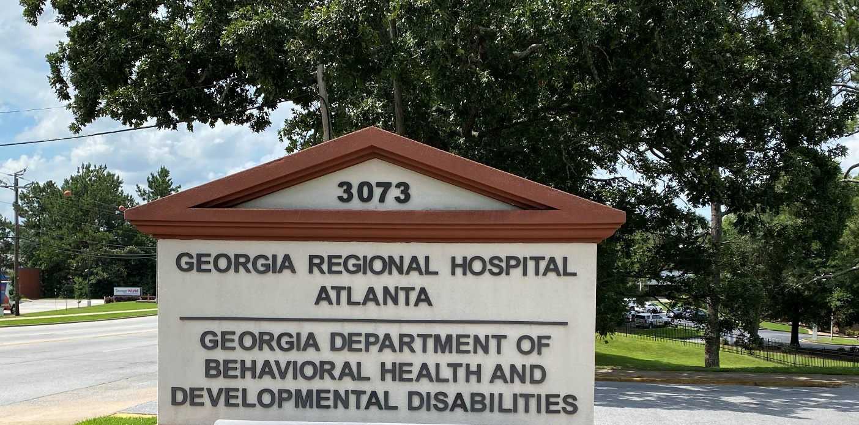

Georgia Regional Hospital at Atlanta (GRH-A) is a publicly owned facility of the State of Georgia and operated by the Department of Behavioral Health and Developmental Disabilities (DBHDD). GRH-A is located on 174 acres in the city of Decatur, directly adjacent to the city of Atlanta.

While the Atlanta metropolitan area may be best known for having the world’s busiest airport, it is also aptly nicknamed the “city in a forest” due to its abundant tree cover. In addition to green spaces and beautiful parks, the Atlanta metro area is also home to state-of-the-art sports stadiums, innovative restaurants, and a bustling arts and film industry. The latter has given Atlanta the moniker “Hollywood of the south.” As well as being a modern and vibrant area, Atlanta played an important role in the civil rights movement which can be re-visited at the renowned Martin Luther King, Jr. National Historic Park.

For more information about the Atlanta metro area:

https://www.exploregeorgia.org/city/atlanta?utm_medium=cpc&utm_source=google&utm_campaign=evg&gclid=EAIaIQobChMIq6CrzIXP8gIVDa7ICh0PvA47EAAYASAAEgKbxfD_BwE

https://discoveratlanta.com/

GRH-A operates 306 licensed, accredited inpatient beds for three major program areas: 1) Adult Mental Health, 2) Adult Forensic Services, and 3) Developmental Disabilities/Skilled Nursing. The hospital serves a large number of underserved groups including adults who are economically disadvantaged, homeless, from diverse racial or ethnic groups, and/or who have severe mental illness. No one is refused admission to the hospital because of inability to pay for services. GRH-A seeks to maximize the continuity of services, thereby helping those hospitalized to retain the gains they make while at the hospital.

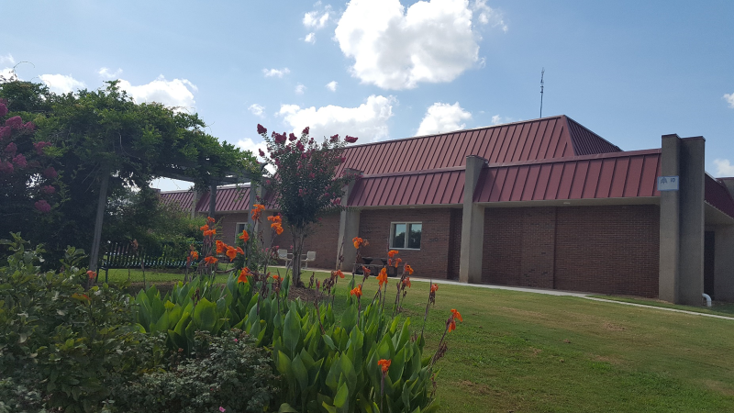
Building 10 – Psychology and Other Discipline Offices

Aim and Mission of the Internship
Our training program is strongly influenced by the desire to provide high quality psychological services to the individuals (i.e., clients or patients) described above. The aim of the Georgia Regional Hospital-Atlanta (GRH-A) Psychology Doctoral Internship Program is to deliver supervised clinical training to doctoral-level interns in the person-centered, evidence-based treatment of adults who experience serious mental illness (SMI). We train interns in established profession-wide competencies through the supervised provision of clinical, forensic, and behavioral psychological services and program evaluation within a state inpatient hospital setting. Furthermore, the Internship’s mission is consistent with DBHDD’s mission: Leading an accountable and effective continuum of care to support Georgians with behavioral health challenges and intellectual and developmental disabilities in a dynamic health care environment.

Philosophy, Goals, and Training Objectives
GRH-A Psychology Internship faculty believe that a psychologist best develops from a combination of self-awareness, theoretical knowledge, analytical skills, and communication skills integrated with quality, supervised experiences. We provide training through progressive, criteria-referenced, supervised experiences with individuals with complex presentations, with an aim to increase the availability of future psychologists who are equipped to make sound therapeutic decisions in difficult clinical situations. Importantly, we also know from experience that students provide an increase in enthusiasm, clinical knowledge, and range of services we can provide, making interns a vital part of our therapeutic community.
Workspace for Various Disciplines
The internship program follows a practitioner-scholar training model designed to prepare students for professional practice with emphasis on understanding and applying psychological research. The internship program trains interns as generalist practitioners equipped with knowledge and skills in clinical and forensic psychology and related program evaluation. Through learning and application of the theories, methods, and skills in each of these areas, we believe that interns will be equipped with a wide range of skills that will optimally prepare them for professional independent practice with a diverse client population. To support the use of evidence-based practice and keeping abreast of emerging clinical research, GRH-A Psychology staff are committed to a department-wide learning orientation, engaging in regular dialogue and peer-consultation and use of learning resources including online journal access and SMI specific training resources.

The Doctoral Psychology Internship Program at GRH-A is accredited by the Commission on Accreditation of the American Psychological Association. The training competencies and related elements for the GRH-A doctoral psychology internship program are consistent with the nine profession-wide competencies identified in the American Psychological Association Standards of Accreditation.

APA Standards of Accreditation Profession-Wide Competencies
i. Research
ii. Ethical and legal standards
iii. Individual and cultural diversity
iv. Professional values, attitudes, and behaviors
v. Communication and interpersonal skills
vi. Assessment
vii. Intervention
viii. Supervision
ix. Consultation and interprofessional/interdisciplinary skills
Overview of Internship

The doctoral psychology internship at GRH-A aims to provide a wide array of meaningful training experiences. The internship lasts 12 months and includes training with an adult, inpatient, individually and culturally diverse population of individuals. Interns choose either a Forensic Psychology track or an Adult Mental Health Clinical Psychology track. Within each track interns will rotate between different treatment units. In addition, interns participate in a in a Program Evaluation and Consultation project for approximately four hours per week. Interns also participate in weekly didactic activities, group supervision, individual supervision, and opportunities to learn about and practice supervision of other mental health professionals.
Flowers from
Therapeutic Garden

Interns work between 40 and 45 hours per week. Sequentially, interns shadow a psychologist on the unit, work under close supervision of their supervisors, and increasingly assume an independent role in providing psychological services to individuals and in their consultations with treatment teams.

The internship program at GRH-A is designed to help interns meet the licensure requirements set forth by the Georgia Board of Examiners of Psychologists, including but not limited to a 2000-hour internship with at least 500 hours of direct contact. Efforts are made to provide interns with didactic training regarding licensure preparation and prerequisites.

GRH-A has made changes to the ways we work and operate due to the ongoing COVID-19 pandemic. Most importantly, prioritizing the safety of all hospital staff including psychology interns, as well as the people we serve. As an inpatient setting, we continue to provide primarily in-person services, with some opportunities for phone or videoconferencing in cases when an individual has been found to be positive for COVID-19 or if a treatment unit was directly exposed to COVID-19. As a hospital we follow CDC and Georgia Department of Public Health guidance closely to prevent and reduce the spread of COVID-19 in a variety of ways. This currently includes mandating masks for all staff and encouraging all staff and individuals we serve to get a COVID-19 vaccination.

Orientation

Interns are required to attend and successfully complete a general, hospital-wide orientation program through the DBHDD University prior to psychology internship-specific orientation with the internship co-directors. Additional hospital-wide online and in-person trainings must also be successfully completed as those training requirements emerge throughout the internship year. Following the general orientation period, interns will orient with their unit supervisor on the particular components of each track and gradually assume clinical responsibilities in coordination with their supervisors.

Tracks & Training Activities

Adult Mental Health (AMH)
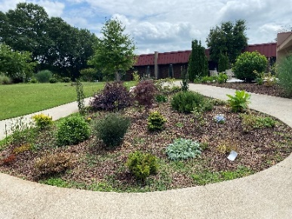
The GRH-A AMH units provide short-term care of individuals who present with acute and chronic psychiatric issues from different referral sources in the community such as emergency departments, walk-ins, community mental health agencies and other facilities. Currently, there are three AMH units with about 40 individuals on each unit. On the AMH track, the intern participates in major rotations of about 4 months each on the AMH units, along with minor rotations in areas of special focus and interest, as well as learning and practicing supervision skills during the second half of the year. On a daily basis interns join and contribute to recovery planning meetings consisting of an interdisciplinary team of professionals meeting as a group with individuals admitted to GRH-A. During any given week interns provide individual therapy, facilitate group therapy at the Psychosocial Rehabilitation Mall, provide behavioral interventions, and complete comprehensive integrative psychological evaluations as well as brief, focused evaluations over the course of the year. The diversity of the population served, and complexity of presenting issues provides a rich opportunity for training. Interns will be able to choose areas of interest/focus that will add variety and flexibility to the training year.
East Unit Therapeutic Garden

Forensic
The GRH-A Forensic units are considered medium-security residential units that house adults who require competency evaluation pertaining to a legal case. There are three units with about 40 individuals each. On the Forensic track, interns participate in two six-month major rotations, one on a short-term Incompetent to Stand Trial unit and a long-term civil commitment unit, as well as two six-month minor rotations, one in outpatient evaluation, and one in learning skills and practice in the provision of supervision. Assessment activities an intern can expect on the Forensic track include risk assessment, competency to stand trial evaluations, evaluations of malingering and effort, and completion of an annual review of civil commitment, as well as referral-based assessments (i.e., personality testing, cognitive/intellectual testing, neuropsychological and dementia screening). Forensic interns provide individual and group therapy throughout the year, interdisciplinary consultation, and learn about Georgia mental health laws for civil commitment.
Forensic Unit Fenced Area for outdoor recreation

Program Evaluation and Consultation (PEC) project
Both AMH and Forensic interns participate in a year-long PEC project that provides training and supervision in using program evaluation and consultation methods to identify and evaluate clinical programs, policies, and/or treatment approaches based on a combination of intern interest and hospital program needs. Throughout the year, interns work with a psychologist supervisor using a variety of methods including literature review, interview and assessment of relevant staff and individuals, data collection, and data analysis to better understand the topic, summarize relevant issues, and provide recommendations for changes and improvements. The
PEC includes two primary components: a series of consultation meetings with an identified team or focus group, and a final written report with recommendations. Interns engage in approximately four hours of PEC-related activity each week. Examples of previous intern PEC projects include the use of telehealth in the inpatient hospital setting, impact of COVID-19 precautions on GRHA operations and a hospital-wide survey on trauma informed care.

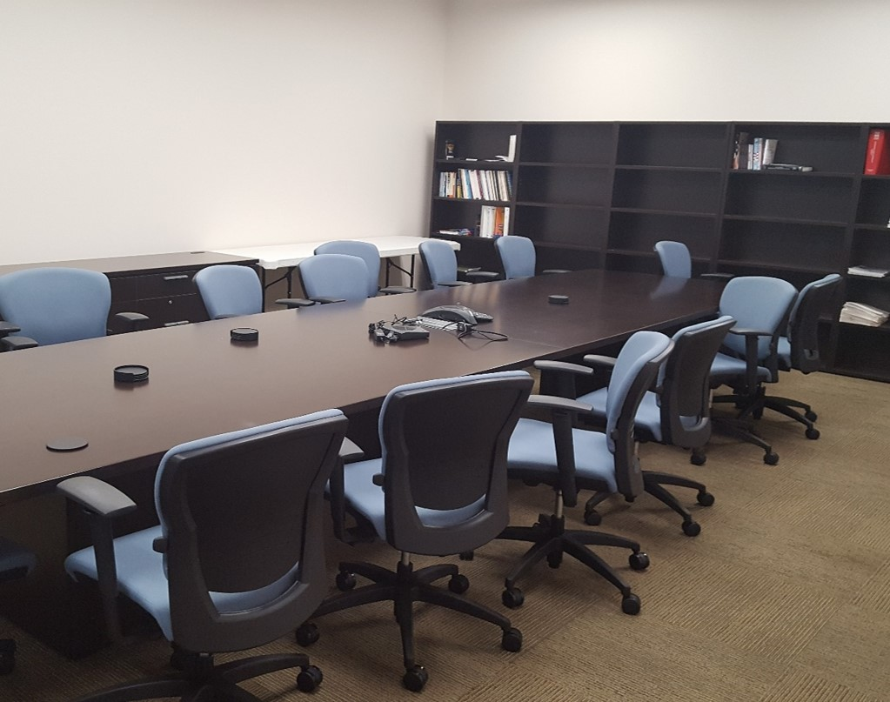
Building 10 Conference Room

Supervision
Each intern has a unit supervisor and works closely with other licensed psychologists who provide clinical supervision in specific areas. At set intervals during the year, interns will switch treatment units and unit supervisors. Throughout the year, the intern meets regularly with the Intern Training Coordinator and the Program Evaluation and Consultation project supervisor Interns participate in one hour of group supervision per week conducted by one or more members of the Psychology Internship Committee.

Seminars & Additional Training Opportunities
In addition to weekly individual and group supervision, interns participate in a wide range of didactic training activities such as:

Intern Seminars: The purpose is to provide focused learning of knowledge and skills necessary to complete the training elements and related advancement of competencies for the GRH-A internship. Topics include: forensic services, diversity, interdisciplinary consultation, severe mental illness, recovery model, assessment, clinical supervision, as well as additional topics relevant to internship training.
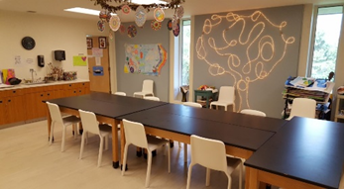
Supervision Skills Practice: Interns have the opportunity to practice supervision skills in a group setting with licensed and unlicensed master’s level counselors meeting for group supervision. Participants present and discuss clinical cases as well as how to navigate systemic issues that may impact clinical work. This group is facilitated by a licensed psychologist, who provides supervision of the intern’s supervision skills practice.
Psychosocial Rehabilitation Mall Art Therapy Room
Psychology Peer Consultation: A monthly meeting of psychologists, mental health counselors psychology interns, and other clinical staff with the purpose of exchanging information and experiences related to the professional practice of psychology through presentations of relevant topics and clinical case studies. This group is facilitated by a licensed psychologist.

Other didactic learning opportunities: Web-based grand rounds from Emory University and Augusta University, continuing education events sponsored by DBHDD, GRH-A clinical review meetings, a Georgia licensing board meeting, internship and post-doctoral events in the Atlanta area, and regular ongoing discussions with interdisciplinary treatment team members.

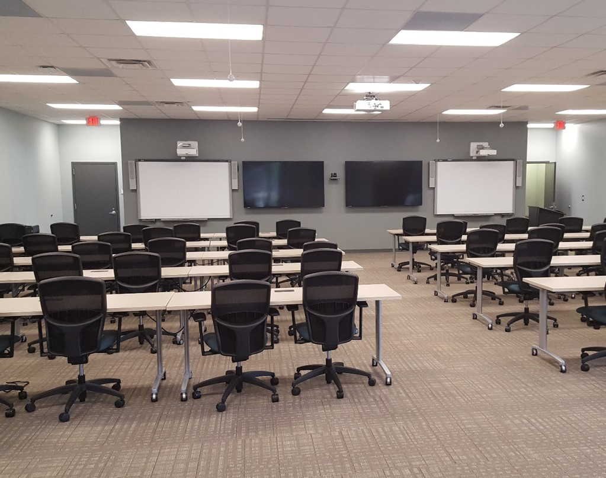
Training & Conference Center Meeting Room

Expectations of Interns &
Evaluation of Intern Performance and Progress

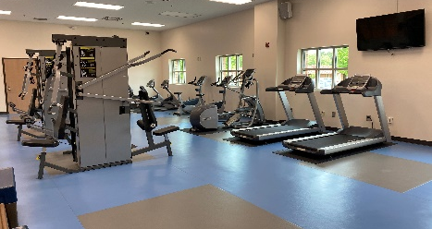
Formal evaluation of intern performance is a vital aspect of the GRH-A psychology internship program. Written evaluations of interns are completed every three months incorporating feedback from all supervisors involved in training at the time of evaluation. Evaluations are completed to provide the intern with professional observations and constructive feedback as the internship progresses. Evaluations focus on interns’ areas of strength and areas that need improvement. Interns are expected to be open and receptive to feedback from supervisors, and the evaluations are designed to be supportive of the intern’s strengths and facilitate the intern’s professional growth as they progress through the training year. The evaluations align very closely with the competencies listed earlier in the Philosophy, Goals, and Objectives section of this brochure, and interns are expected to demonstrate satisfactory progress with identified elements of the professional-wide competencies as the training year progresses. Interns complete self-assessments of their skills and progress toward becoming knowledgeable and skilled in the professional-wide competencies as well as their own identified professional goals at the beginning and midpoint of each year.
Weight Room Adjacent to Gym

Due process and grievance procedures are outlined in the interns’ training handbook and discussed with interns during the orientation process.
Intern Schedule of Activities
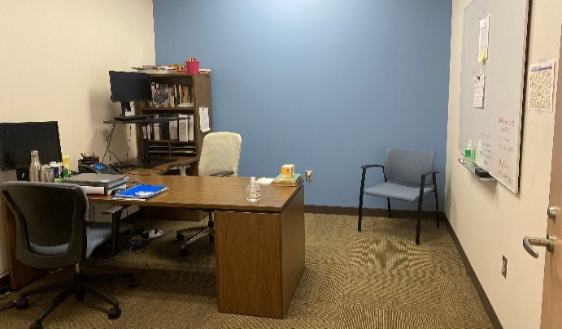
Intern Shared Office
Each intern keeps a weekly hours log of internship activities, which records the number of hours spent in individual and group supervision, direct clinical contact, seminars/didactic training, additional support activities, and other important clinical facets. Each intern’s daily and weekly schedules may vary somewhat. However, given hospital orientation, 12 state holidays, and 15 days of annual/sick leave, interns must average the following weekly and annual requirements to adequately meet the standards for internship training set forth by the Georgia Board of Examiners of Psychologists:

Sample Daily Schedule
Morning rounds |  | 8:00 – 8:30 a.m.
Interdisciplinary team mtg |  | 8:30 – 9:30 a.m. |  |  |  |  |  | 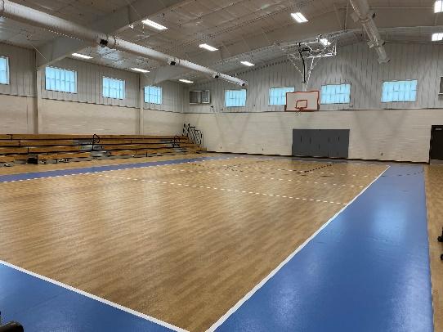  Indoor Gymnasium 1  2  Indoor Gymnasium 3
Chart review |  | 9:30 – 10:00 a.m.
Individual therapy |  | 10:00 – 11:00 a.m.  1  Psychosocial Rehabilitation Mall 1  Psychosocial Rehabilitation Mall 2  PSR Mall 1
Group therapy |  | 11:00 – 12:00 p.m.
Lunch |  | 12:00 – 12:30 p.m.
Chart review |  | 12:30 – 1:00 p.m.
Psychological testing |  | 1:00 – 2:00 p.m. |  |  |  |  |  | Indoor Gymnasium
Individual supervision |  | 2:00 – 3:00 p.m. |  |  |  |  |  | Indoor Gymnasium
Report and note writing |  | 3:00 – 4:30 p.m.
Annual Requirements
Direct, face-to-face individual (i.e., client or patient) contact |  |  |  |  |  |  |  |  | 500 hours
Total internship hours |  |  |  |  |  |  |  |  | 2,000 hours

Weekly Requirements = 40-45 hours (Hours in parentheses are not calculated in the Total)
Individual supervision |  |  |  |  |  |  |  |  | 3 hours
Group supervision |  |  |  |  |  |  |  |  | 1 hour
Didactic training |  |  |  |  |  |  |  |  | 2-4 hours
Direct, face-to-face clinical services |  |  |  |  |  |  |  |  | 10-12 hours
Group therapy |  |  |  |  |  |  |  |  | (3 hours)
Individual therapy  Assessment (clinical interviewing, mental status examinations, and test administration) |  |  |  |  |  |  |  |  | (3-4 hours)  (2-5 hours)
PEC focused activities  Non-direct contact assessment activities (e.g., test scoring &  report-writing) |  |  |  |  |  |  |  |  | (4 hours)  (2-5 hours)
Treatment team meetings & morning rounds |  |  |  |  |  |  |  |  | 10 hours
Progress notes/communication/  records review/administrative |  |  |  |  |  |  |  |  | 10 hours
Intern/peer consultation |  |  |  |  |  |  |  |  | 1 hour
Internship-related home study |  |  |  |  |  |  |  |  | 1 hour

Eligibility Requirements

Minimum qualifications
Applicants must be currently enrolled in an APA accredited doctoral program in clinical or counseling psychology which grants a degree of PhD or PsyD. Applicants are expected to have passed their clinical competency exam, or equivalent, and must have completed at least 60 semester hours of graduate-level course work (excluding internship and dissertation hours) at their graduate institution prior to inception of the internship. Completion of the dissertation prior to the inception of the internship is recommended but not a requirement.

Applicants are expected to have completed, or be in the process of completing, multiple practica experiences under the direct supervision of a licensed psychologist. Total completed practica hours including intervention, assessment, supervision, and support should meet a minimum of 1000 hours. However, the GRH-A internship program recognizes the potential impact of COVID-19 on practicum hours this year and will take this into consideration when reviewing applications. It is also expected that applicants demonstrate knowledge and behavior that make evident a commitment to adhering to the APA Ethical Principles of Psychologists and Code of Conduct.

In addition to these requirements, applicants must meet all requirements to be employed by the State of Georgia. This includes having a pre-employment screening, which will be arranged through the Human Resources department. As are all employees for the State of Georgia, interns are required to successfully complete mandatory random drug screenings, criminal background checks, reference verification, and other human resources requirements. The internship program has no jurisdiction over employment-related decisions resulting from a positive drug screen or adverse criminal history, and interns should be aware of this as they apply. The interns, as state employees, are paid twice a month and accrue five (5) hours of annual and five (5) hours of sick leave every pay period. During orientation, the interns are given additional information to make benefit selection decisions that are available to them as a state employee.

Preferred qualifications
In addition to the above minimum qualifications, the ideal candidate will demonstrate the following:
- Prior clinical psychology experience in an inpatient setting
- Coursework and/or clinical training in the field of forensic psychology (Forensic track only)
- An interest in working in inpatient settings, with underserved populations, and with people with severe mental illness
- Well-developed clinical-writing skills
- Interest and demonstrated ability to work effectively with diverse populations

Application Process

The GRH-A Doctoral Psychology Internship Program has approval for two internship positions for the 2022-2023 training year. Questions not answered by the information in this brochure can be sent to the co-director of psychology internship training, Dr. Mark Cochran, at Mark.Cochran@dbhdd.ga.gov.

A completed application should consist of:
- Cover letter
- Completed AAPI
- Updated curriculum vitae (include contact email address and phone number)
- Copies of unofficial transcripts from the current graduate institution (official transcripts not necessary)
- Three letters of reference
- Verification of internship eligibility from the director of clinical training at the intern’s graduate institution
- De-identified psychological evaluation report completed during a supervised training experience (i.e., practicum)
This program will be participating in the 2021-22 APPIC Match. Instructions for applying to the internship program are found on APPIC’s website at www.appic.org. The GRH-A program code is 2259. This internship site has agreed to abide by all APPIC policies, including the policy that no person at this training facility will solicit, accept, or use any ranking-related information from any intern applicant.

Intern Selection Process

Focused efforts are made during the interviewing and selection process to ensure that the applicant’s educational and practicum experiences are consistent with the GRH-A Internship Program’s philosophy and training objectives and are appropriate for doctoral training in professional psychology. The applicant’s experience is evaluated through review of the AAPI, internship eligibility verification statement/letter, curriculum vitae, written work sample, graduate transcripts, and letters of reference. There is an emphasis on selecting applicants who are evaluated to have the highest likelihood of successful participation and completion of the internship training program based on previous experience, acquired skill sets, and interest in working with GRH-A’s population.
Flowers from One of the Therapeutic Gardens

Georgia Regional Hospital-Atlanta is an equal opportunity employer and does not discriminate on the basis of race, color, national origin, sex, religion, age or disability in employment. An applicant who has a disability that requires special accommodations should contact the co-director of psychology internship training. The GRH-A Psychology Internship Program recognizes the significance and value of individual and cultural diversity and provides training and supervision in diversity with regard to increasing awareness and ability to function competently in providing culturally informed clinical practice.

Internship Committee

Elizabeth Bradshaw-Livingston, PhD
GRH-A Position: Co-Director of Internship Training, Assistant AMH Program Director
Graduate Institution: Western Michigan University
Areas of specialization/training: Social Justice Issues, Identity Development, Culturally Informed Treatment, Acceptance and Commitment Therapy, Mindfulness Approaches, Anxiety Disorders, Supervision and Training

Mark Cochran, PsyD
GRH-A Position: Co-Director of Internship Training, AMH Program Director
Graduate Institution: Loyola University Maryland; The University of Texas at Austin
Areas of specialty/training: Clinical Psychology, Cognitive Assessment, Cognitive Behavior Therapy, ADHD, Memory, Geropsychology

Stephanie Davis, PsyD
GRH-A Position: Forensic Psychologist
Graduate Institution: Georgia Southern University
Areas of specialty/training: Forensic Psychology/Assessment, Severe and Persistent Mental Illness

Audrey Owens Day, PhD
GRH-A Position: AMH Psychologist
Graduate Institution: The City College of New York, CUNY (formally The Graduate School, CUNY)
Areas of specialty/training: Clinical Psychology, Psychological Assessment, Behavioral Intervention

Ashley N. Douroux, PsyD
GRH-A Position: Forensic Program Director
Graduate Institution: University of LaVerne; LaVerne, California
Areas of specialty/training: Forensic Assessment (Competency, Malingering, and Risk); Expert Testimony and Serious Mental Illness

Amy Gambow, PhD
GRH-A Position: Forensic Psychologist
Graduate Institution: Palo Alto University
Areas of specialty/training: Forensic Psychology and Assessment, Severe and Persistent Mental Illness

Jason Hall, PhD
GRH-A Position: Forensic Psychologist
Graduate Institution: University of Minnesota
Areas of specialty/training: Forensic Assessment, Competency Restoration, Psychopathy, Severe and Persistent Mental Illness

Sarah Howell, PsyD
GRH-A Position: AMH Psychologist
Graduate Institution: Albizu University, Miami, Florida
Areas of specialty/training: Neuropsychology, Geropsychology, Dementia, Acceptance and Commitment Therapy, Adjustment Disorders, Assessing Severe and Persistent Mental Illness

Javel Jackson, PsyD
GRH-A Position: AMH Psychologist
Graduate Institution: Virginia Consortium for Professional Psychology
Areas of specialty/training: Psychodynamic Theory, Gender-Responsive Programming, Grief and Loss Issues, Trauma-Informed Interventions, Supervision and Training

Trish Marquardt, PsyD
GRH-A Position: AMH Psychologist
Graduate Institution: Georgia School of Professional Psychology
Areas of specialization/training: Clinical Psychology, Adult, Child and Adolescent, Recovery Oriented Cognitive Therapy with SMI Individuals

Shenell S. Myrie, PsyD
GRH-A Position: Forensic Psychologist
Graduate Institution: The Illinois School of Professional Psychology
Areas of specialty/training: Forensic Assessment, Child and Adolescent Testing and Therapy, Clinical Psychology

Madinah Ralston, PhD
GRH-A Position: AMH Psychologist
Graduate Institution: Kent State University
Areas of specialty/training: Clinical Psychology, Cognitive Behavioral Therapy with Children, Adolescents and Adults; ADHD, Psychological Assessment

Eduardo Vargas, PsyD
GRH-A Position: Forensic Psychologist
Graduate Institution: Nova Southeastern University
Areas of specialty/training: Psychological Assessment, Competency Evaluations, Competency Restoration Treatment, Violence Risk Assessment, Serious and Persistent Mental Illness, Substance Abuse Issues, Culturally Informed Treatment, Group and Individual Therapy

Rhonda L. Williams, PhD
GRH-A Position: AMH Psychologist
Graduate Institution: Hofstra University
Areas of specialty/training: Cognitive-Behavioral Approaches to Group Therapy, Culturally Sensitive Assessment, Behavioral Consultation

Internship Admissions, Support, and Initial Placement Data
Date Program Tables are updated: 8/27/21
Program Disclosures
Does the program or institution require students, trainees, and/or staff (faculty) to comply with specific policies or practices related to the institution’s affiliation or purpose? Such policies or practices may include, but are not limited to, admissions, hiring, retention policies, and/or requirements for completion that express mission and values? |  |  |  |  |  |  | __X___ Yes  _____ No
If yes, provide website link (or content from brochure) where this specific information is presented:
Interns are required to attend and successfully complete a general, hospital-wide orientation program through the DBHDD University prior to psychology internship-specific orientation with the internship co-directors. Additional hospital-wide online and in-person trainings must also be successfully completed as those training requirements emerge throughout the internship year. (brochure p.6)
Applicants must meet all requirements to be employed by the State of Georgia. This includes having a pre-employment screening, which will be arranged through the Human Resources department. As are all employees for the State of Georgia, interns are required to successfully complete mandatory random drug screenings, criminal background checks, reference verification, and other human resources requirements. The internship program has no jurisdiction over employment-related decisions resulting from a positive drug screen or adverse criminal history, and interns should be aware of this as they apply. (brochure p.13)

Internship Program Admissions
Briefly describe in narrative form important information to assist potential applicants in assessing their likely fit with your program. This description must be consistent with the program’s policies on intern selection and practicum and academic preparation requirements:
Georgia Regional Hospital-Atlanta (GRH-A) is an inpatient psychiatric state hospital in the metropolitan area of Atlanta, Georgia. The internship program currently has two full-time doctoral psychology positions. The intern chooses one of two tracks, either on adult inpatient mental health (civil commitment) units, or on adult inpatient forensic services units. During the entire training year, all interns participate in a focused concentration project relevant to the work of psychologists in this setting, using program evaluation and consultation methods to identify and evaluate clinical programs and approaches. For the forensic track, applicants should have had coursework and/or clinical training in a forensic psychology setting. For either track, a good fit for our program would be applicants who have prior clinical experience in an inpatient setting or working with SMI in any setting; an interest in working in inpatient settings, with underserved populations with severe mental illness; well-developed report-writing skills; and the ability to work with diverse populations.

Does the program require that applicants have received a minimum number of hours of the following at time of application? If Yes, indicate how many:
Total Direct Contact Intervention Hours | No |  | Amount: NA
Total Direct Contact Assessment Hours | No |  | Amount: NA

Describe any other required minimum criteria used to screen applicants:
The minimum requirements for the GRH-A Psychology Doctoral internship program include the applicant is currently enrolled in a psychology PhD or PsyD program, has completed at least 60 semester hours in that program and has passed the required clinical comprehensive exam, and that total completed practica hours including intervention, assessment, supervision and support should meet a minimum of 1000 hours. However, the GRH-A internship program recognizes the potential impact of COVID-19 on practicum hours this year and will take this into consideration when reviewing applications.

Financial and Other Benefit Support for Upcoming Training Year*
Annual Stipend/Salary for Full-time Interns | $25,342
Annual Stipend/Salary for Half-time Interns | NA
Program provides access to medical insurance for intern? | (Yes) | No
If access to medical insurance is provided:
Trainee contribution to cost required? | (Yes) | No
Coverage of family member(s) available? | (Yes) | No
Coverage of legally married partner available? | (Yes) | No
Coverage of domestic partner available? | Yes | (No)
Hours of Annual Paid Personal Time Off (PTO and/or Vacation) | 120 (5/pay period)
Hours of Annual Paid Sick Leave | 120 (5/pay period)
In the event of medical conditions and/or family needs that require extended leave, does the program allow reasonable unpaid leave to interns/residents in excess of personal time off and sick leave? | (Yes) | No
Other Benefits (please describe):
GRH-A psychology interns are employees of the State of Georgia while here as an intern. As such, they are able to purchase elective health, dental, vision, legal, disability, accidental death and dismemberment insurance. Health care and child-care spending accounts and life and dependent life insurance are also available on an elective basis. Employees participate in the Employee Retirement System. Contributions are based on a percentage of salary. Group Term Life insurance is provided to all members of the Employee Retirement System. Tax shelter plans are available that enable employees to provide for greater retirement security. Fund programs are available in both 457 and 401(k) plans. Employees are eligible to become members of the Human Services Employee Credit Union.
All use of leave must take into consideration the requirements of completing 2,000 hours of logged clinical training as an intern and the program's design that aims for the completion of a doctoral internship in 365 days.
*Note. Programs are not required by the Commission on Accreditation to provide all benefits listed in this table

Initial Post-Internship Positions
(Provide an Aggregated Tally for the Preceding 3 Cohorts)
 | 2017-2020
Total # of interns who were in the 3 cohorts | 6
Total # of interns who did not seek employment because they returned to their doctoral program/are completing doctoral degree | 0
 | PD | EP
Academic teaching | 0 | 0
Community mental health center | 0 | 0
Consortium | 0 | 0
University Counseling Center | 0 | 0
Hospital/Medical Center | 0 | 0
Veterans Affairs Health Care System | 0 | 0
Psychiatric facility | 3 | 0
Correctional facility | 0 | 0
Health maintenance organization | 0 | 0
School district/system | 0 | 0
Independent practice setting | 1 | 2
Other | 0 | 0
Note: “PD” = Post-doctoral residency position; “EP” = Employed Position. Each individual represented in this table should be counted only one time. For former trainees working in more than one setting, select the setting that represents their primary position.

The Doctoral Psychology Internship Program at Georgia Regional Hospital – Atlanta is accredited by the Commission on Accreditation of the American Psychological Association.
Questions related to the program’s accredited status should be directed to the Commission on Accreditation:
Office of Program Consultation and Accreditation
American Psychological Association
750 1st Street, NE, Washington, DC 20002
Phone: (202) 336-5979
Email: apaaccred@apa.org
Web: www.apa.org/ed/accreditation

